Appendix 2

Oxfordshire Partnership Protocol Overview and Safeguarding Board involvement

The diagram below shows where the safeguarding boards fit within the JSNA and key partnerships.

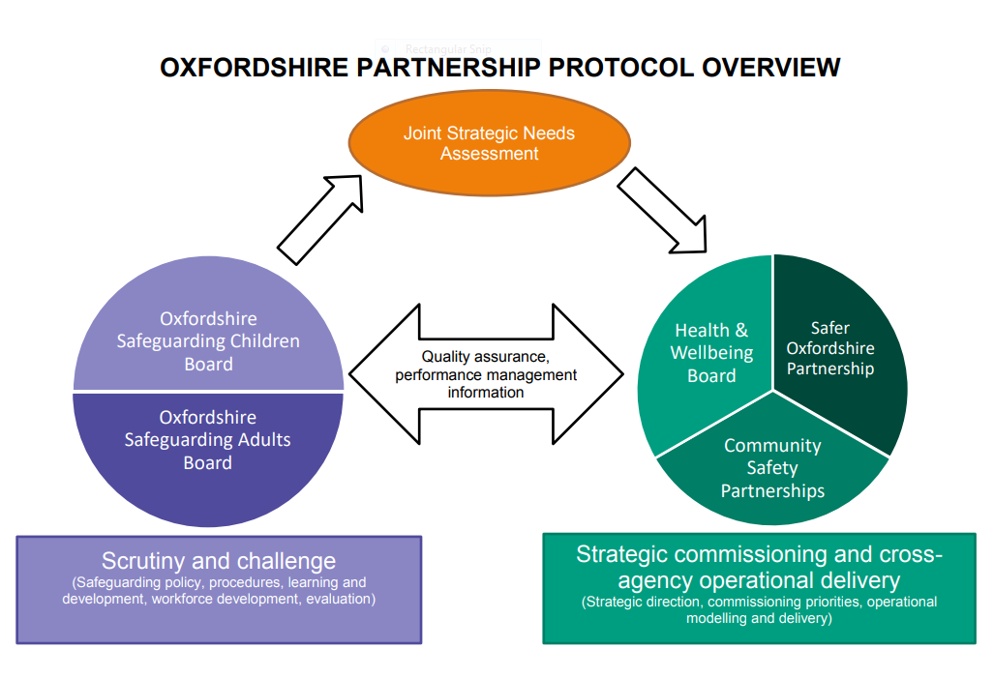

Oxfordshire Multi-Agency Child Safeguarding Arrangement

Draft Structure chart – highlighted areas show Oxford City representation

Executive Group

CEO Oxfordshire County Council
Assistant Chief Constable Thames Valley Police
Accountable Office Clinical Commissioning Group

OSCB Independent Chair, Barnardo’s, Relevant Partners

OSCB Business Group
Strategic Leads and Chairs of Sub-Group, Independent Chair

Sub Groups

Neglect Task & Finish Group

Performance, Audit & Quality Control Procedures Case Review & Governance Training

Child Exploitation Health Advisory Group Child Death Overview Panel

Safeguarding in Education Disabled Children Housing

Oxfordshire Adult Safeguarding Board

The three key members on the Oxfordshire Safeguarding Adults Board are:
• The Director of Adult Social Care, Oxfordshire County Council
• The Director of Quality, Oxfordshire Clinical Commissioning Group
• The Detective Chief Inspector, Protecting Vulnerable People, Thames Valley Police

There are senior representatives on the board from the following organisations:

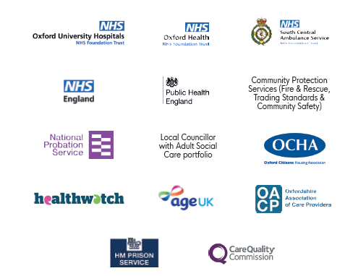

Oxfordshire Adult Safeguard Board structure and sub-group participation

Executive Group

Sub Groups

Performance, information and quality assurance Engagement Group

Adult Safeguarding Review Group Policy and Procedures Group Hoarding

Vulnerable Adult Mortality Group Training Sub Group

